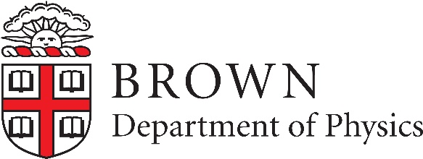

J. Michael Kosterlitz Postdoctoral Fellowship at Brown University
The Department of Physics at Brown University is inviting applications for the J. Michael Kosterlitz Postdoctoral Fellowship. This prestigious fellowship will give outstanding condensed matter theorists an opportunity to work with Prof. J. M. Kosterltiz and the theory group (http://www.brown.edu/academics/physics/areas-research/condensed-matter-theory/condensed-matter-theory) at Brown. The condensed matter theory faculty are engaged in research in hard and soft matter, including statistical mechanics, biophysics, climate physics, mesoscopics, quantum materials, and topological matter. A competitive annual stipend will be offered along with a research and travel fund. Application materials including a CV, statement of research plans, and the names of three references should be submitted electronically to apply.interfolio.com/42052.

Inquiries about this position should be directed to JMK-search@brown.edu or to Prof. Dima Feldman, Chair of the J. Michael Kosterltitz Fellowship Committee, Department of Physics, Box 1843, Brown University, Providence, Rhode Island 02912. Applications received by December 1, 2017 will receive full consideration. Women and minorities are strongly encouraged to apply. Brown University is committed to fostering a diverse and inclusive academic global community; as an EEO/AA employer. Brown considers applicants for employment without regard to, and does not discriminate on the basis of gender, race, protected veteran status, disability, or any other legally protected status.

